SPRINT 1

|  |  |
| --- | --- |
| Date | 7 november 2022 |
| Team ID | PNT2022TMID00922 |
| Project Name | Project – Signs with Smart Connectivity for Better Road Safety |

**Wokwi Simulation**: [Adhifinal_iot.ino - Wokwi Arduino and ESP32 Simulator](https://wokwi.com/projects/348214814486561362)

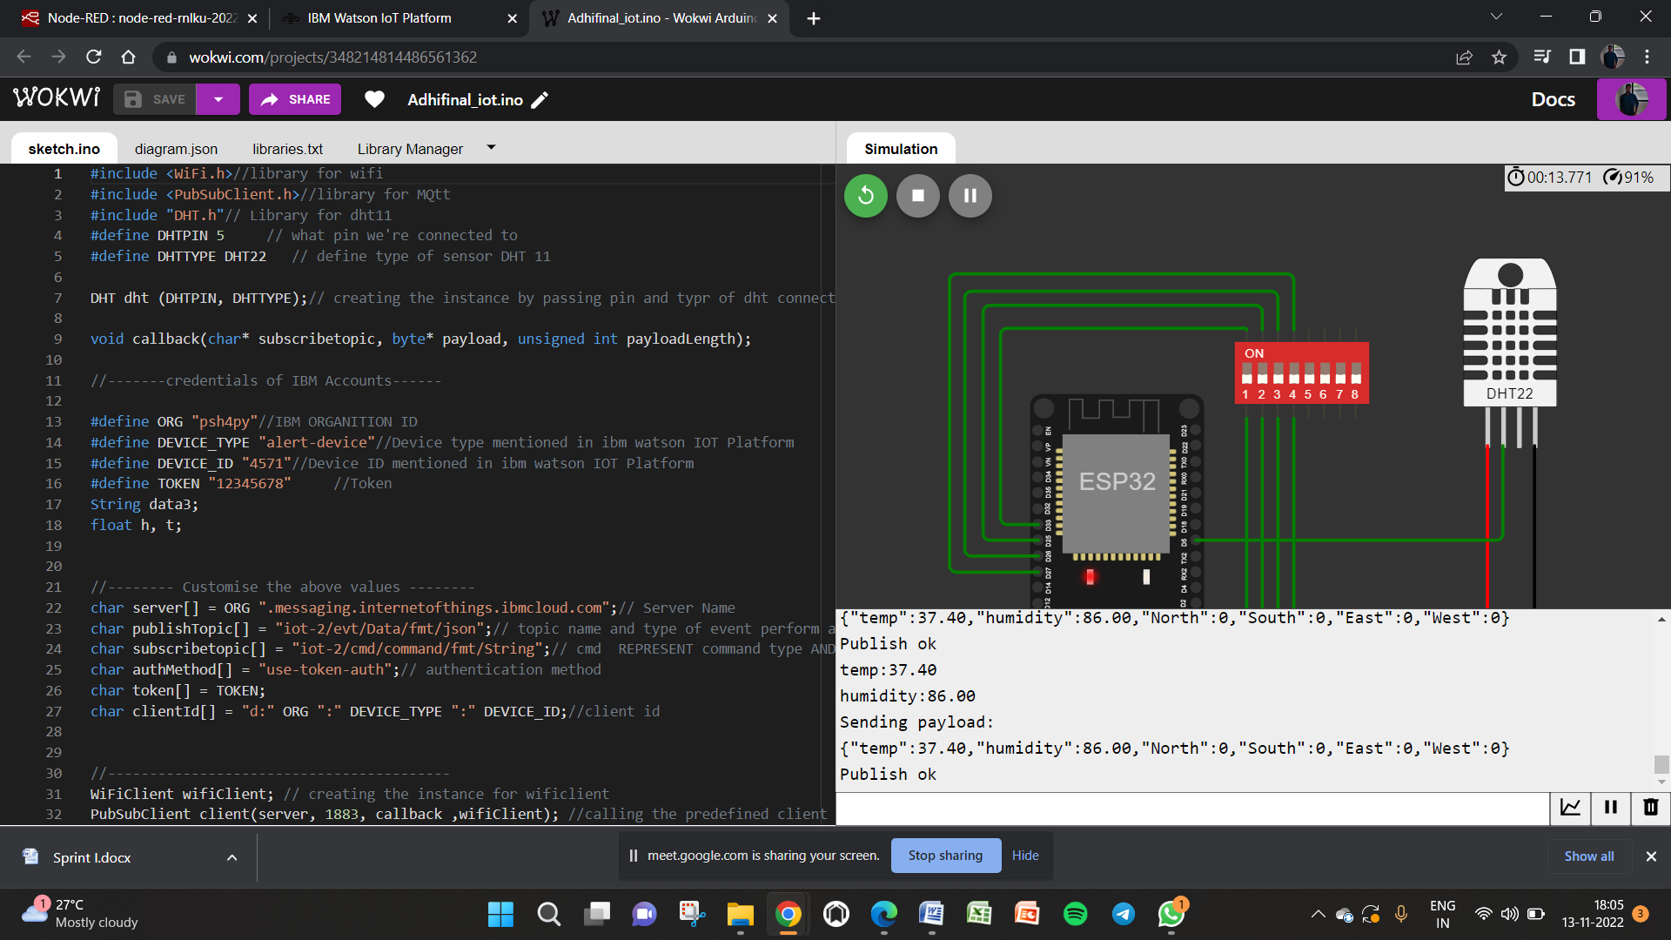

IoT Device – IoT Platform

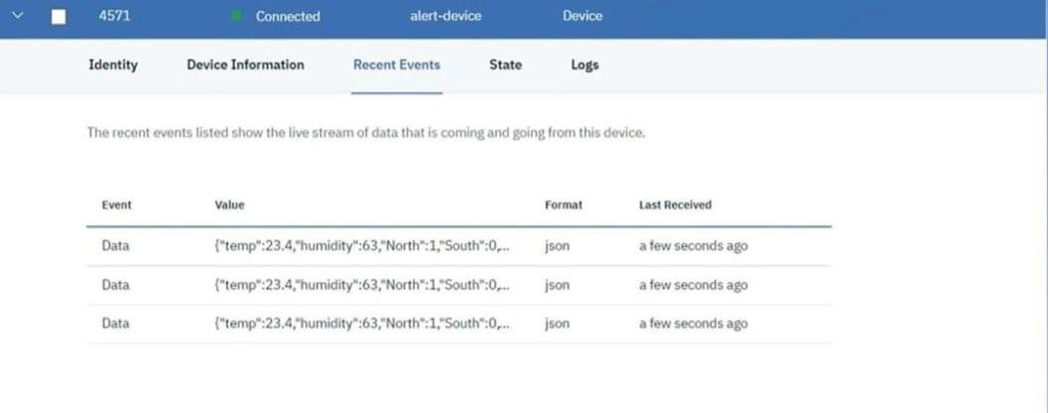

Node Red

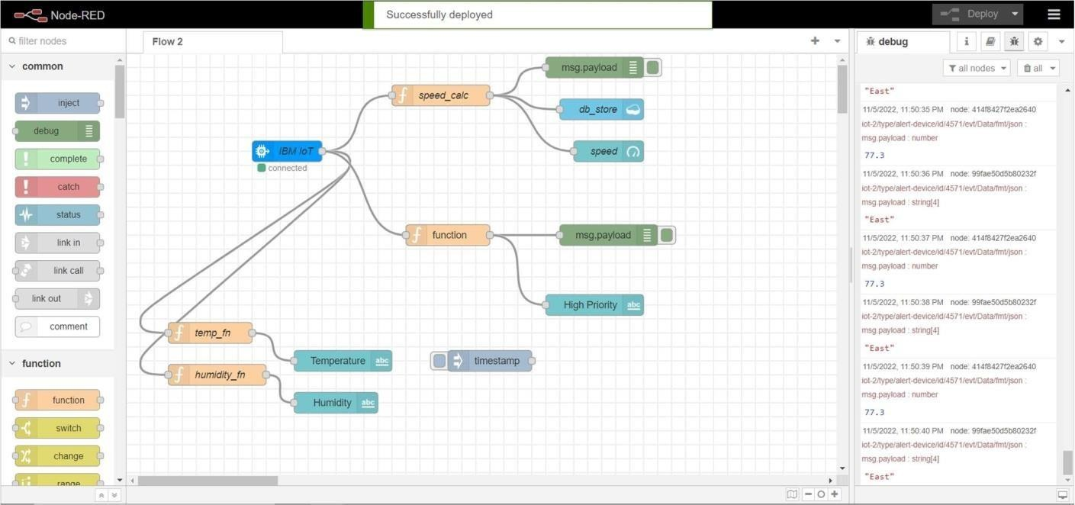

Node Red Web UI

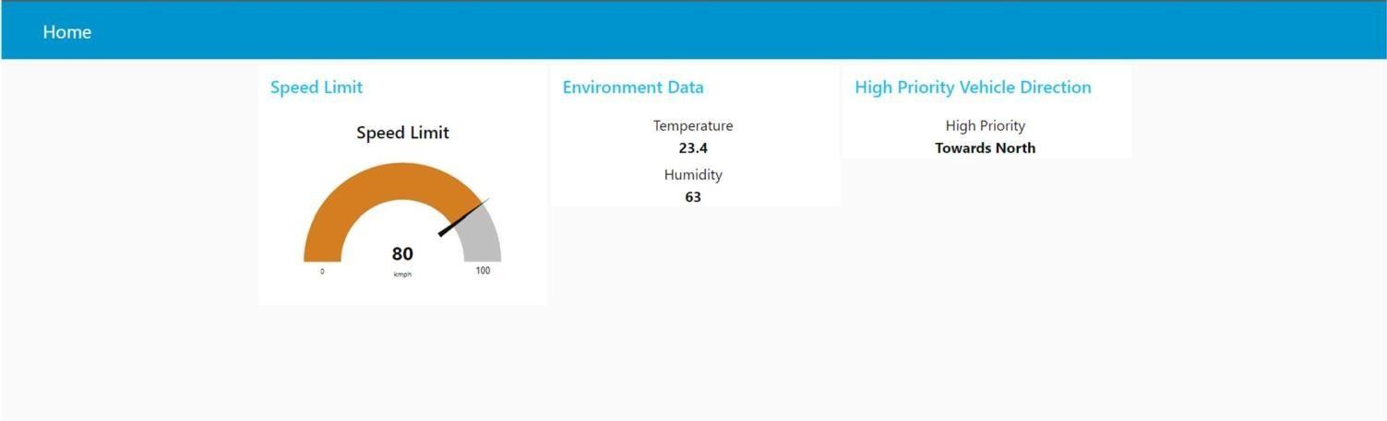

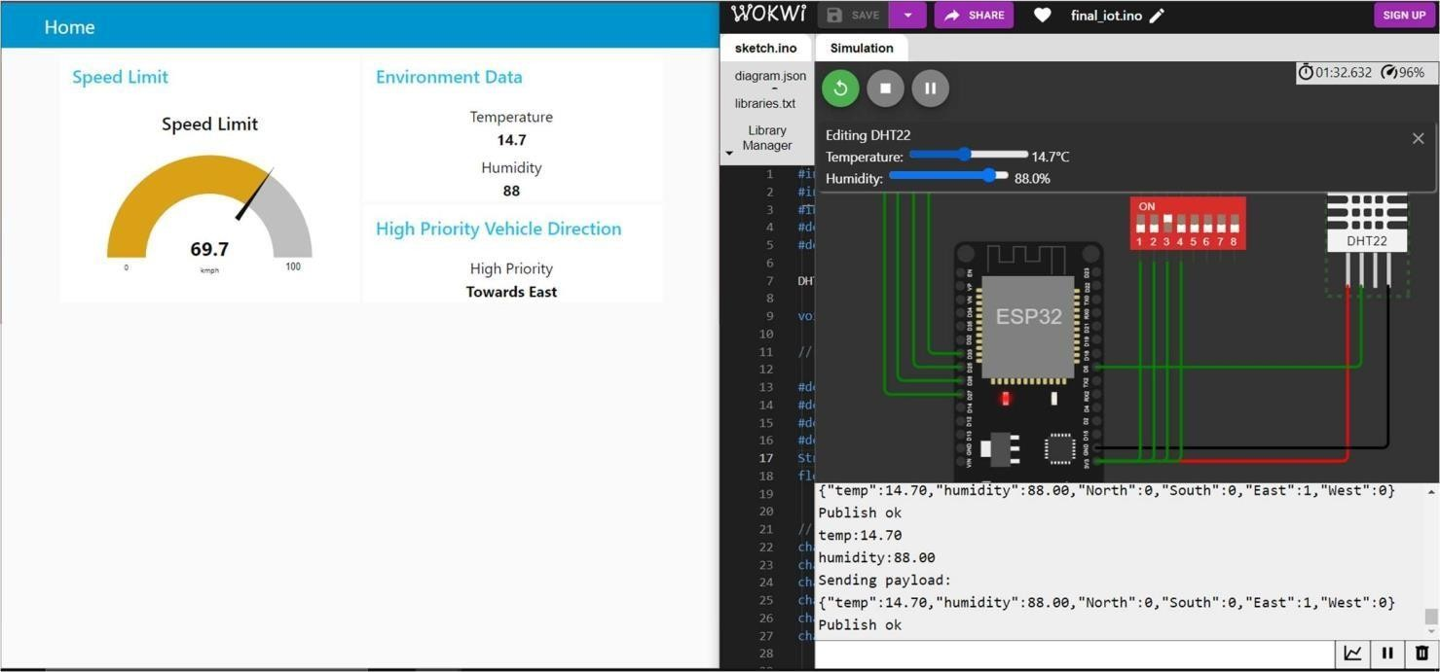

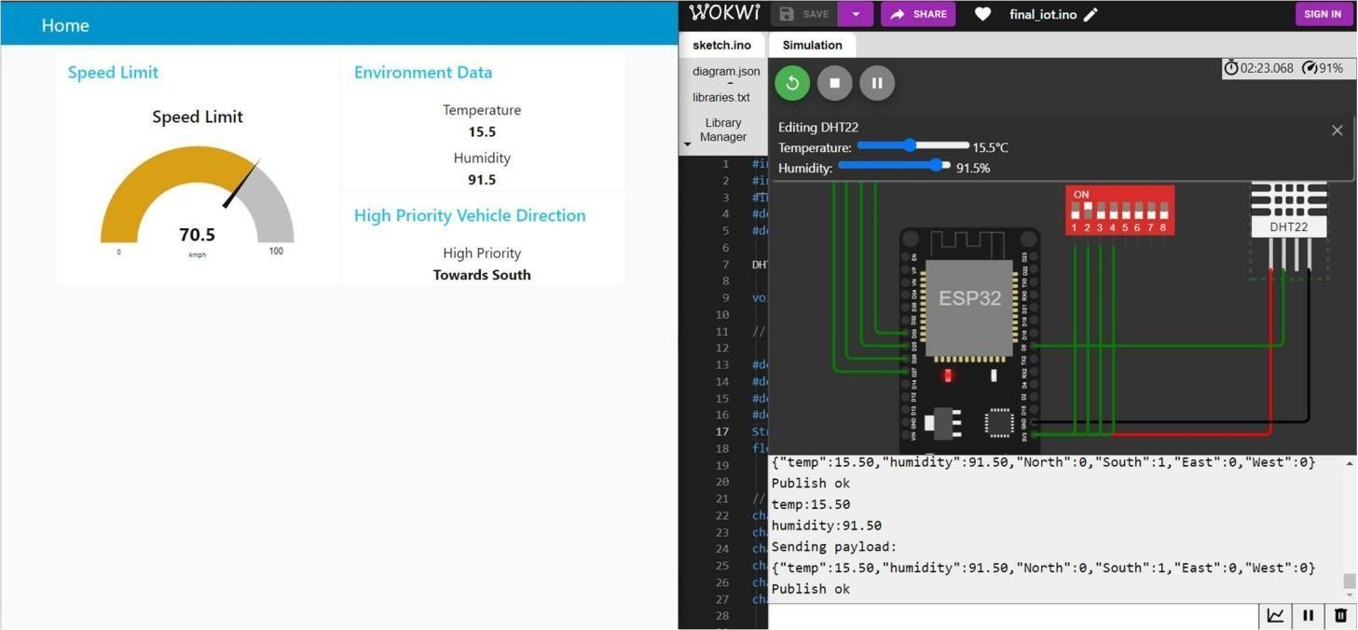

Cloudant Database

